SYSTEM ARCHITECTURE

1. Architectural Strategy
The system uses a completely decoupled, three-tier architectural approach to isolate client-side interactions from background database logic. This division supports clean software component maintenance and scales system boundaries smoothly without affecting adjacent layers.

2. Tier Architecture Layout
- Presentation Tier (React.js): Operates as a single-page application (SPA). It handles client-side views, enforces route guards based on user context, and triggers asynchronous HTTP network requests.
- Logic Tier (Node.js & Express.js): Formulates the core RESTful routing stack. It intercept network events, handles JWT verification middleware, processes validation conditions, and links to the object-document mapper.
- Data Tier (MongoDB): Serves as the persistence engine, storing unstructured documents inside organized collections optimized for quick read and write operations.

3. System Architecture Diagram
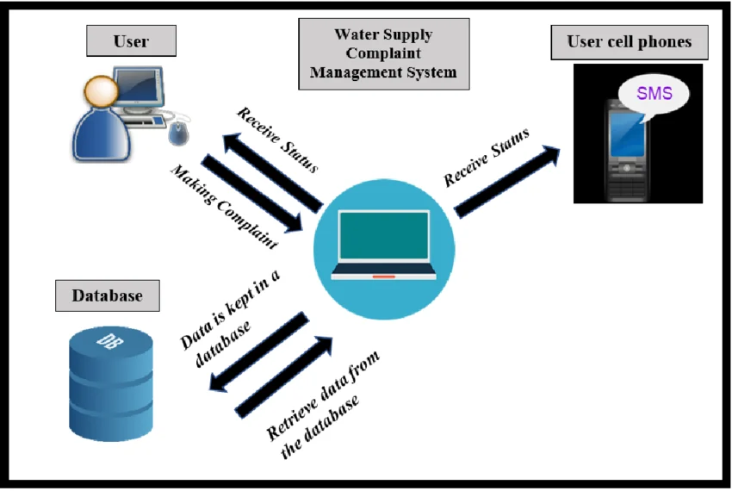

4. Core Schema Specifications
I. Users Schema Fields
Field Target Key | Validation Type | Database Operational Assignment
_id | ObjectId | Primary collection identifier.
username | String | Unique account lookup index string.
password | String | Cryptographically encrypted user credentials.
role | String | Access indicator for RBAC validation filters.

